**Project Planning Phase**

**(Product Backlog, Sprint Planning, Stories, Story points)**

| Date | 20 October 2022 |
| --- | --- |
| Team ID | PNT2022TMID03630 |
| Project Name | Emerging Methods for Early Detection of Forest Fires. |
| Team members | MEKALA BHARGAV,NARIBOYINA PAVAN SAI,MUNJURU BHARADWAJA,N PAVAN |

**Product Backlog, Sprint Schedule, and Estimation**

| **Sprint** | **Functional Requirement (Epic)** | **User Story Number** | **User Story / Task** | **Acceptance criteria** | **Priority** | **Team Members** |
| --- | --- | --- | --- | --- | --- | --- |
| **Sprint - 1** | Data collection and analysing weather conditions. | **USN-1** | **Collecting data from forest such as Humidity,temperature,wind and rain.Evaluating the data.** | **Data collected needs to be correct all the time for best prediction of environment changes** | **High** | **Mekala Bhargav,**  **N.Pavan** |
| **Sprint - 2** |  |  |  |  |  |  |
| **Sprint - 3** |  |  |  |  |  |  |
| **Sprint - 4** |  |  |  |  |  |  |

**Project Tracker, Velocity & Burndown Chart:**

| **Sprint** | **Total Story Points** | **Duration** | **Sprint Start Date** | **Sprint End Date (Planned)** | **Story Points Completed (as on Planned End Date)** | **Sprint Release Date (Actual** |
| --- | --- | --- | --- | --- | --- | --- |
| **Sprint - 1** | **20** | **6 days** | **24 October 2022** | **31 October 2022** | **20** | **30 October 2022** |
| **Sprint - 2** | **20** | **6 days** | **01 November 2022** | **10 November 2022** |  |  |
| **Sprint - 3** | **20** | **6 days** | **11 November 2022** | **13 November 2022** |  |  |
| **Sprint - 4** | **20** | **6 days** | **14 November 2022** | **19 Novmber 2022** |  |  |

**Velocity: Imagine we have a 10-day sprint duration, and the velocity of the team is 20 (points per sprint). Let’s calculate the team’s average velocity (AV) per iteration unit (story points per day)**

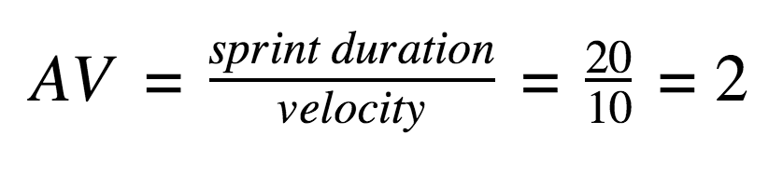

Burndown Chart: A burn down chart is a graphical representation of work left to do versus time. It is often used in agile software development methodologies such as Scrum. However, burn down charts can be applied to any project containing measurable progress over time.

